21BDS0340

Abhinav Dinesh Srivatsa

Exploratory Data Analysis Lab

**Experiment 8.1**

**Code:**

setwd("~/College Work/Year 4 Semester 1 (Sem 7)/Exploratory Data Analysis Lab/Experiment 8-1")

data = read.csv("mtcars.csv")

library(psych)

library(moments)

library(ggplot2)

**Output:**

> setwd("~/College Work/Year 4 Semester 1 (Sem 7)/Exploratory Data Analysis Lab/Experiment 8-1")

> data = read.csv("mtcars.csv")

>

> library(psych)

> library(moments)

> library(ggplot2)

**Code:**

# 1. measures of central tendency

# arithmetic mean

mean(data$hp)

# geometric mean

exp(mean(log(data$hp)))

# harmonic mean

1 / mean(1 / data$hp)

# median

median(data$hp)

# quantiles

quantile(data$hp)

# deciles

quantile(data$hp, probs = seq(.1, 1, by = .1))

# percentiles

quantile(data$hp, probs = seq(.01, 1, by = .01))

**Output:**

> # 1. measures of central tendency

> # arithmetic mean

> mean(data$hp)

[1] 146.6875

> # geometric mean

> exp(mean(log(data$hp)))

[1] 131.8837

> # harmonic mean

> 1 / mean(1 / data$hp)

[1] 118.2289

> # median

> median(data$hp)

[1] 123

> # quantiles

> quantile(data$hp)

0% 25% 50% 75% 100%

52.0 96.5 123.0 180.0 335.0

> # deciles

> quantile(data$hp, probs = seq(.1, 1, by = .1))

10% 20% 30% 40% 50% 60% 70% 80% 90% 100%

66.0 93.4 106.2 110.0 123.0 165.0 178.5 200.0 243.5 335.0

> # percentiles

> quantile(data$hp, probs = seq(.01, 1, by = .01))

1% 2% 3% 4% 5% 6% 7% 8% 9% 10% 11% 12% 13%

55.10 58.20 61.30 62.72 63.65 64.58 65.17 65.48 65.79 66.00 66.00 66.00 66.75

14% 15% 16% 17% 18% 19% 20% 21% 22% 23% 24% 25% 26%

74.50 82.25 90.00 91.54 92.16 92.78 93.40 94.02 94.64 95.26 95.88 96.50 97.48

27% 28% 29% 30% 31% 32% 33% 34% 35% 36% 37% 38% 39%

99.96 102.44 104.92 106.20 107.44 108.68 109.23 109.54 109.85 110.00 110.00 110.00 110.00

40% 41% 42% 43% 44% 45% 46% 47% 48% 49% 50% 51% 52%

110.00 110.00 110.06 110.99 111.92 112.85 115.60 118.70 121.80 123.00 123.00 123.00 126.24

53% 54% 55% 56% 57% 58% 59% 60% 61% 62% 63% 64% 65%

134.61 142.98 150.00 150.00 150.00 150.00 157.25 165.00 172.75 175.00 175.00 175.00 175.00

66% 67% 68% 69% 70% 71% 72% 73% 74% 75% 76% 77% 78%

175.00 175.00 175.40 176.95 178.50 180.00 180.00 180.00 180.00 180.00 180.00 180.00 184.50

79% 80% 81% 82% 83% 84% 85% 86% 87% 88% 89% 90% 91%

192.25 200.00 206.10 209.20 212.30 215.60 220.25 224.90 229.55 234.20 238.85 243.50 245.00

92% 93% 94% 95% 96% 97% 98% 99% 100%

245.00 245.00 247.66 253.55 259.44 268.97 290.98 312.99 335.00

**Code:**

# 2. measures of dispersion

# range

max(data$hp) - min(data$hp)

# inter quantile range

quantile(data$hp, 0.75) - quantile(data$hp, 0.25)

# inter decile range

quantile(data$hp, probs = seq(.1, 1, by = .1))["90%"] - quantile(data$hp, probs = seq(.1, 1, by = .1))["10%"]

# mean absolute deviation

mad(data$hp)

# standard deviation

sd(data$hp)

# skewness

skewness(data$hp)

# kurtosis

kurtosis(data$hp)

**Output:**

> # 2. measures of dispersion

> # range

> max(data$hp) - min(data$hp)

[1] 283

> # inter quantile range

> quantile(data$hp, 0.75) - quantile(data$hp, 0.25)

75%

83.5

> # inter decile range

> quantile(data$hp, probs = seq(.1, 1, by = .1))["90%"] - quantile(data$hp, probs = seq(.1, 1, by = .1))["10%"]

90%

177.5

> # mean absolute deviation

> mad(data$hp)

[1] 77.0952

> # standard deviation

> sd(data$hp)

[1] 68.56287

> # skewness

> skewness(data$hp)

[1] 0.7614356

> # kurtosis

> kurtosis(data$hp)

[1] 3.052233

**Code:**

# 3. frequency distributions with plots

# frequency distribution

table(cut(mtcars$hp, breaks = 5))

# histogram

hist(data$hp)

# relative frequency distribution

prop.table(table(cut(mtcars$hp, breaks = 5)))

# cumulative frequency distribution

cumsum(table(cut(data$hp, breaks = 5)))

**Output:**

> # 3. frequency distributions with plots

> # frequency distribution

> table(cut(mtcars$hp, breaks = 5))

(51.7,109] (109,165] (165,222] (222,278] (278,335]

10 9 8 4 1

> # histogram

> hist(data$hp)

> # relative frequency distribution

> prop.table(table(cut(mtcars$hp, breaks = 5)))

(51.7,109] (109,165] (165,222] (222,278] (278,335]

0.31250 0.28125 0.25000 0.12500 0.03125

> # cumulative frequency distribution

> cumsum(table(cut(data$hp, breaks = 5)))

(51.7,109] (109,165] (165,222] (222,278] (278,335]

10 19 27 31 32

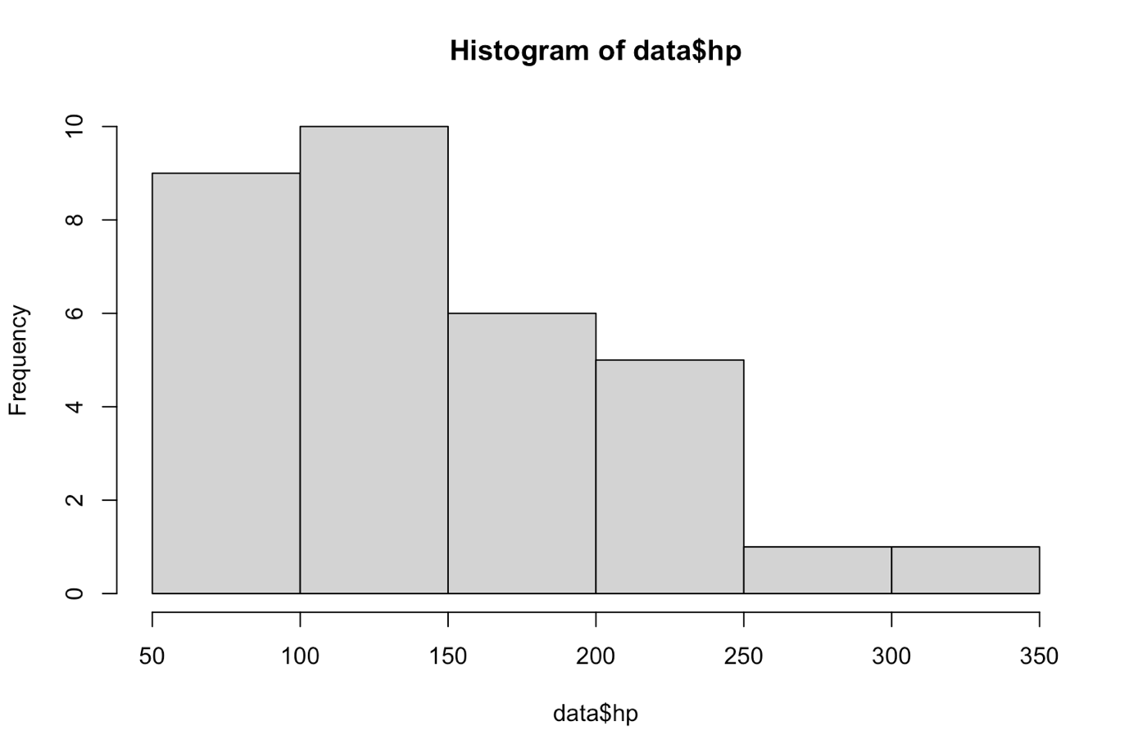

**Code:**

# 4. plots from the categorical variable

# pie chart

pie(table(data$cyl))

# bar plot

barplot(table(mtcars$cyl))

**Output:**